Costs

This paragraph will discuss the costs associated with the project and any potential gain that this project can bring. It is intended to see if the project is justified to continue.

The current HoneyJar project has a funding of €40.000 which has been granted from the A Danish Research Network. So the €40.000 will be taken used as the whole funding for the entire project.

When this project is concluded in half a year ideally everything has been done. Realistically this won’t be possible since the architecture that is currently standing is very basic and needs a lot of improving. When this is done machine learning has to be implemented. Since the project members that are going to work on this aren’t familiar with it this will take a lot of time as well.

While it is still unclear on what exactly will be delivered, for now it seems like it’s going into the direction of an antivirus system with machine learning incorporated in it. So this is what will be used in the following example.

Whenever an antivirus is created there has to be a good understanding of the operating system it will run on, in this case that will be android. The group has to be up-to-date with malware trends so that it can update the system accordingly. Even with machine learning in place it is important to give updates where needed. If machine learning will be the only way of detecting malware, new malware might slip through the cracks. Also a proper programming language must be mastered.

So now the following has been established:

* Architecture needs ***a lot***of work
* Machine learning is new to the current project group
* There probably won’t be enough time to finish the created vision

Even though there probably won’t be enough time to finish an end product it is still possible to create an estimate on the revenue that the potential finished product will make.

So let’s say that this product will cost €40.000 to make. With this €40.000 a basic product will be made to show the basic functionalities. Further development will require more money of course. Also for this example assume that the product will be sold as a service to consumers who will pay an average of €60 per calendar year.

So right now the product is a SaaS with a subscription for consumers. See the following business model canvas. €40.000 is nothing to create an app this size but, it will be the baseline to create the fundamental features.

Labor costs will be included in the €40.000 for now. As said previously this will include all the work to create a basic system. However with this basic system money will not be earned, yet. For this future development is needed. Since it is hard to predict the future an assumption has to be made on how long this development will take.

Now that a product has been sketched an assumption can be made about the money it will cost and bring in once it’s finished.

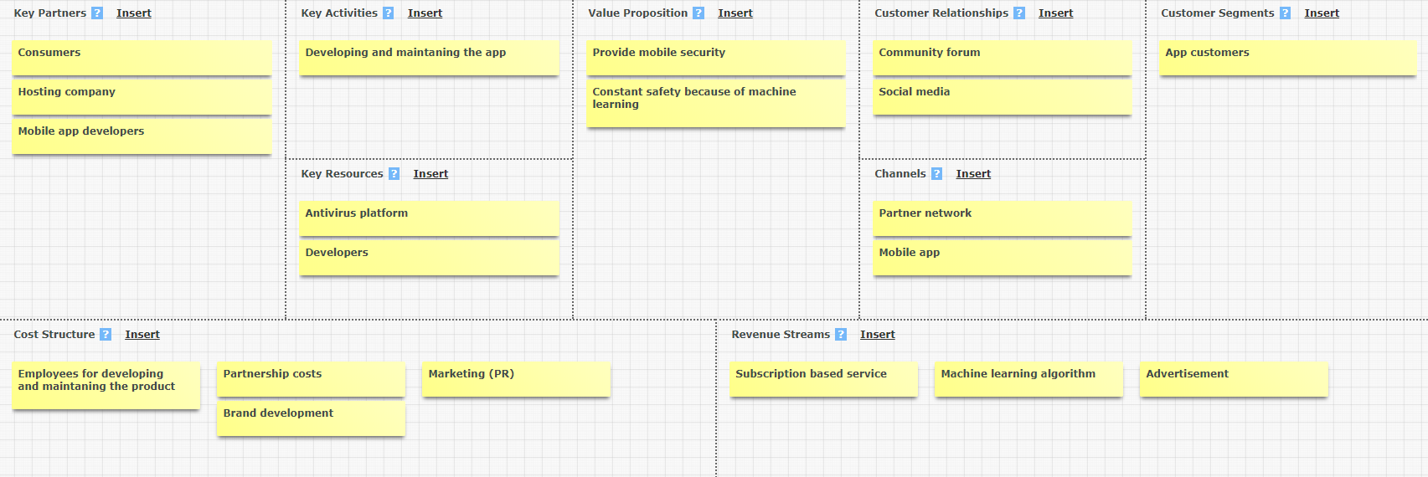**Business model canvas:**

Labor costs will be included in the €40.000 for now. As said previously this will include all the work to create a basic system. However with this basic system money will not be earned, yet. For this future development is needed.

Now that a product has been sketched an assumption can be made about the money it will cost and bring in once it’s finished.

|  |  |  |
| --- | --- | --- |
|  | Estimated € needed |  |
| Basic system development | € 40.000 |  |
| Development for a marktable product | € 300.000 |  |
| **Total development costs** | **€ 340.000** |  |
|  |  |  |
|  |  |  |
| Future improvements and support costs (annually) | € 120.000 |  |
| Partnership costs | € 31.250.000 | 25% of profit |
| Marketing | € 12.500.000 | 10% of profit |
| Brand development | € 12.500.000 | 10% of profit |
| **Total** | **€ 56.370.000** |  |
|  |  |  |
| **Gain money (annual)** |  |  |
| Subscription | € 120.000.000 | avg €5p/month with 2million users |
| Machine learning algotrithm | € 5.000.000 | avg €5000p/month with 1000 businesses |
| **Total** | **€ 125.000.000** |  |
|  |  |  |
|  |  |  |
| **ACTUAL PROFIT PER YEAR** | **€ 68.630.000** |  |

Development for a marketable product has a price of €300.000 because the assumption has been made that it’ll be developed by people that’ll work on this app full time (40hrs/week) for a period of half a year to a year.